 

# INTERNSHIP PROJECT

**BY**

**HR DATA ANALYSIS USING SQL**

**Thenmozhi R**

LOADING THE DATA

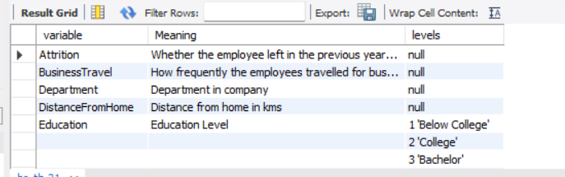

1. Retrieve the total number of employees in the dataset

SELECT COUNT(Empoyee_id) As no_of_Employees FROM hr_tb1;

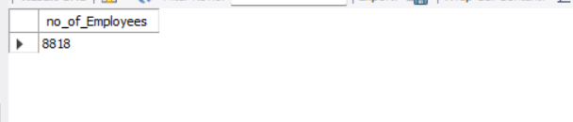

2. List all unique job roles in the dataset.

SELECT DISTINCT(Job_Role) FROM hr_tb1;

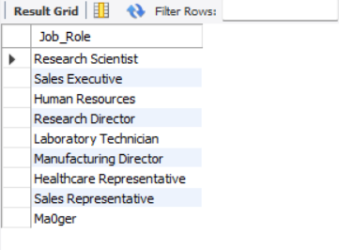

3. Find the average age of employees.

SELECT AVG(Age) FROM hr_tb1;

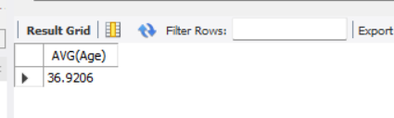

4. Retrieve the names and ages of employees who have worked at the company for more than 5 years.

SELECT emp_name, Age

FROM hr_tb1

WHERE Years_At_Company > 5;

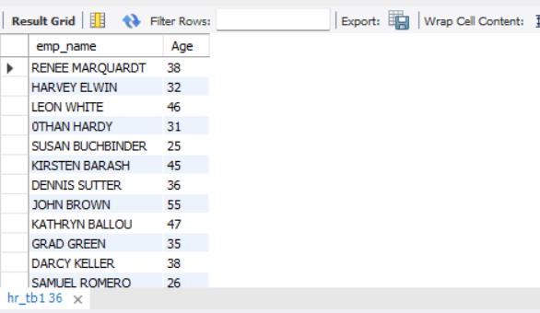

5. Get a count of employees grouped by their department

SELECT COUNT(empoyee_id),Department FROM hr_tb1 GROUP BY

Department;

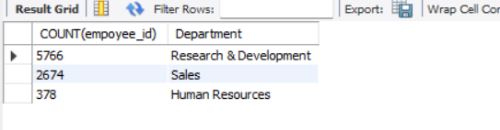

6. List employees who have 'High' Job Satisfaction.

SELECT hr_tb1.Empoyee_iD,Emp_Name,hr_tb2.Job_Satisfaction

FROM hr_tb1 JOIN hr_tb2 ON hr_tb1.Empoyee_iD =

hr_tb2.Employee_ID ORDER BY Job_Satisfaction DESC;

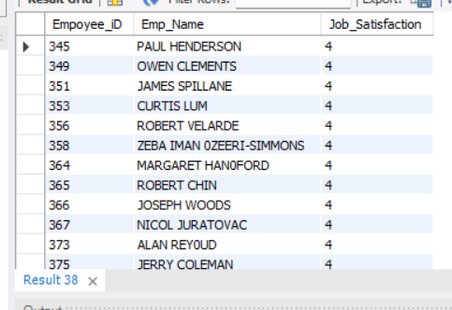

7. Find the highest Monthly Income in the dataset.

SELECT MAX(Monthly_Income) FROM hr_tb1;

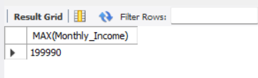

8. List employees who have 'Travel_Rarely' as their BusinessTravel type.

SELECT Emp_Name FROM hr_tb1 WHERE Business_Travel IN

('Travel_Rarely');

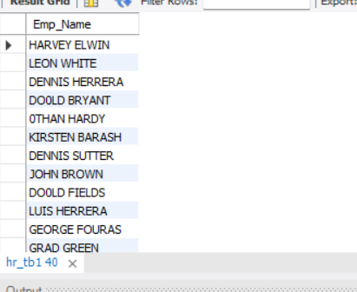

9. Retrieve the distinct MaritalStatus categories in the dataset.

SELECT DISTINCT(Marital_Status) FROM hr_tb1;

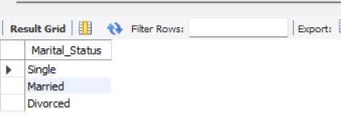

10. Get a list of employees with more than 2 years of work experience but less than 4 years in their current role.

SELECT Emp_Name FROM hr_tb1 WHERE Total_Working_Years IN(2,4);

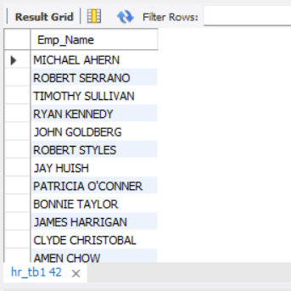

11. List employees who have changed their job roles within the company (JobLevel and JobRole differ from their previous job).

SELECT Emp_Name

FROM hr_tb1

WHERE Job_Level != Job_Role

LIMIT 0, 50000;

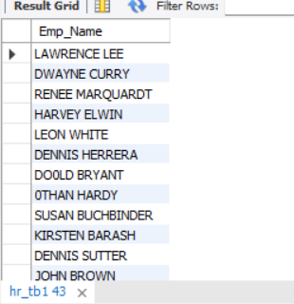

12. Retrieve the top 5 employees with the highest MonthlyIncome

SELECT Monthly_Income, Emp_Name

FROM hr_tb1

ORDER BY Monthly_Income DESC

LIMIT 5;

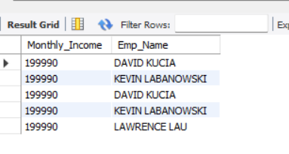

13. Find the average distance from home for employees in each department.

SELECT Department,AVG(Distance_From_HOME)AS Avg_Distance FROM

hr_tb1 GROUP BY Department;

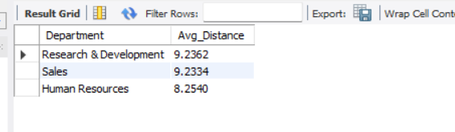

14. List the employees with the highest and lowest Environment Satisfaction.

SELECT Employee_ID,Environment_Satisfaction AS High_Environment_Satisfaction

FROM hr_tb2 Where Environment_Satisfaction = 4

UNION ALL

SELECT Employee_ID,Environment_Satisfaction AS Low_Environment_Satisfaction

FROM hr_tb2 Where Environment_Satisfaction = 1 ;

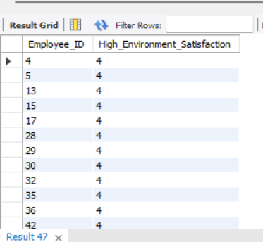

15. Calculate the percentage of employees who have had a promotion in the last year

SELECT COUNT(*)*100/(SELECT COUNT(*) FROM hr_tb1) AS

Promotion_percentage FROM hr_tb1 WHERE Years_Since_Last_Promotion=1;

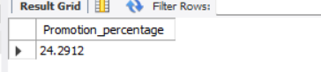

16. Find the employees who have the same Job Role and Marital Status

SELECT a.empoyee_id, a.job_role, b.job_role, a.marital_status, b.marital_status from

hr_tb1 a join hr_tb1 b on a.Empoyee_ID=b.Empoyee_ID

where a.Job_Role=b.job_role and a. Marital_Status=b.Marital_Status;

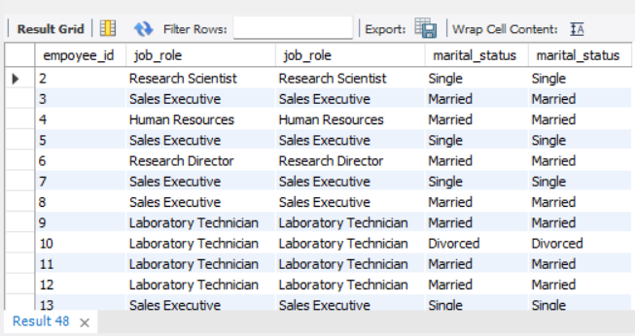

17. List the employees with the highest Total Working Years who also have a Performance Rating of 4.

SELECT hr_tb1.Empoyee_ID,hr_tb1.Total_Working_Years,

Performance_Rating FROM hr_tb1 JOIN hr_tb2 ON

hr_tb1.Empoyee_ID =hr_tb2.Employee_ID WHERE

hr_tb2.Performance_Rating=4

ORDER BY hr_tb1.Total_Working_Years DESC ;

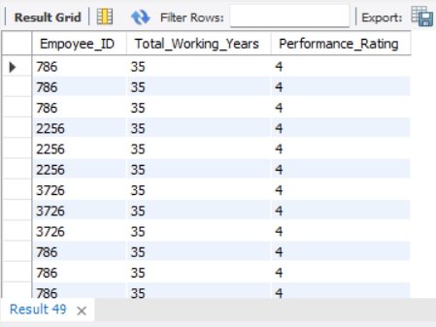

18. Calculate the average Age and JobSatisfaction for each BusinessTravel type.

select distinct Business_travel,avg(age)over(partition by Business_travel)as avgage from hr_tb1;

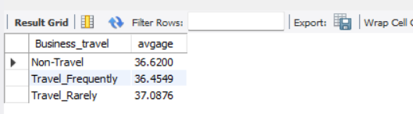

19. Retrieve the most common Education Field among employees.

SELECT Education_Field FROM hr_tb1 GROUP BY Education_Field ORDER

BY Education_Field DESC;

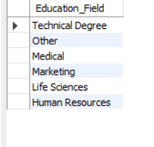

20. List the employees who have worked for the company the longest but haven't had a promotion.

SELECT Empoyee_ID,MAX(Years_At_Company)AS Max_no_of_years FROM

hr_tb1 WHERE Years_Since_Last_Promotion =0 GROUP BY Employee_ID

ORDER BY Max_no_of_years DESC ;

